|  |  |
| --- | --- |
| **ChangeManagerControllers** | |
| **Physical address** | admin/application/controllers |
| **Base class** |  |
| **Attributes** | |
| N/A | |
| **Operations** | |
| index() | |
| **Return Type** | void |
| **Parameters** | N/A |
| checkPermission() | |
| **Return Type** | void |
| **Parameters** | N/A |

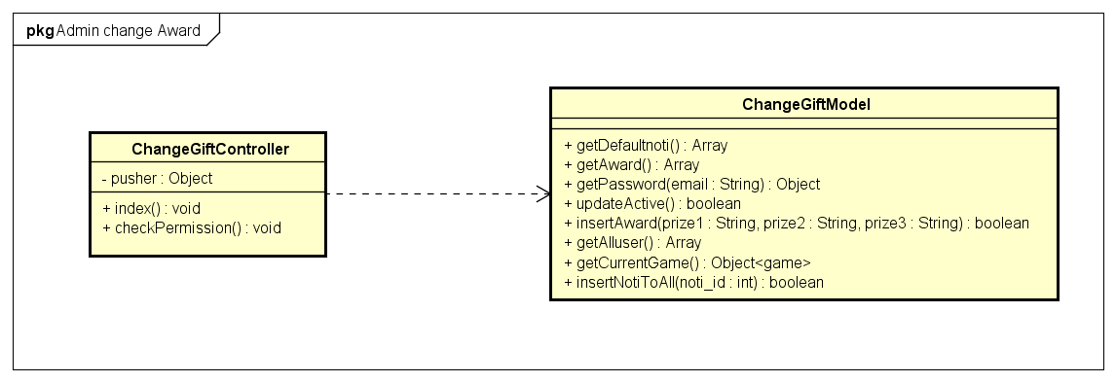

|  |  |  |  |
| --- | --- | --- | --- |
| **ChangeGiftModel** | | | |
| **Physical address** | admin/application/models | | |
| **Base class** |  | | |
| **Attributes** | | | |
| N/A | | | |
| **Operations** | | | |
| getDefaultNoti() | | | |
| **Return type** | Array | | |
| **Parameters** | N/A | | |
| getAward() | | | |
| **Return type** | Array | | |
| **Parameters** | N/A | | |
| getPassword() | | | |
| **Return type** | Admin object | | |
| **Parameters** | **Name** | **Type** | **Description** |
|  | email | String | The admin email |
| updateActive() | | | |
| **Return type** | Boolean | | |
| **Parameters** | N/A | | |
|  |  | | |
| insertAward() | | | |
| **Return type** | boolean | | |
| **Parameters** | **Name** | **Type** | **Description** |
|  | Prize1 | String | The prize 1 award name |
|  | Prize2 | String | The prize 2 award name |
|  | Prize3 | String | The prize 2 award name |
| getAllUser() | | | |
| **Return type** | Array | | |
| **Parameters** | N/A | | |
| getCurrentGame() | | | |
| **Return type** | Object | | |
| **Parameters** | N/A | | |
| insertNotiToAll() | | | |
| **Return type** | boolean | | |
| **Parameters** | **Name** | **Type** | **Description** |
|  | noti_id | int | The noti id to insert to all user |